**Static Routing**

**Designed Topology:**

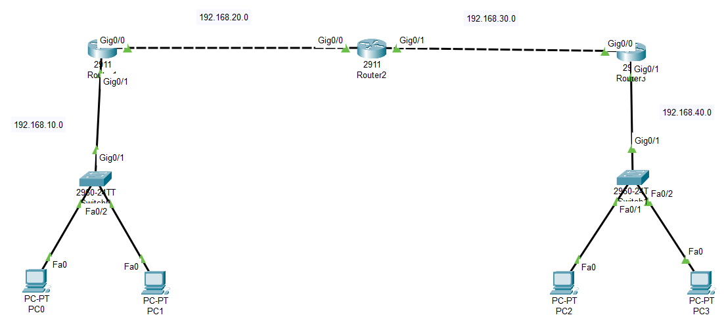

**Configuration of Router1:**

Router>enable

Router#config terminal

Router(config)#hostname R1

R1(config)#int Gig0/1

R1(config-if)#ip address 192.168.10.1 255.255.255.0

R1(config-if)#no shutdown

R1(config-if)#exit

R1(config)#int Gig0/0

R1(config-if)#ip address 192.168.20.1 255.255.255.0

R1(config-if)#no shutdown

R1(config-if)#exit

R1(config)#ip route 192.168.30.0 255.255.255.0 192.168.20.2

R1(config)#ip route 192.168.40.0 255.255.255.0 192.168.20.2

R1(config)#exit

R1(config)#sh ip route

R1#write

**Configuration of Router2:**

Router>enable

Router#config terminal

Router(config)#hostname R2

R2(config)#int Gig0/1

R2(config-if)#ip address 192.168.30.1 255.255.255.0

R2(config-if)#no shutdown

R2(config-if)#exit

R2(config)#int Gig0/0

R2(config-if)#ip address 192.168.20.2 255.255.255.0

R2(config-if)#no shutdown

R2(config-if)#exit

R2(config)#ip route 192.168.10.0 255.255.255.0 192.168.20.1

R2(config)#ip route 192.168.40.0 255.255.255.0 192.168.30.2

R2(config)#exit

R2#sh ip route

R2#write

**Configuration of Router3:**

Router>enable

Router#config terminal

Router(config)#hostname R3

R3(config)#int Gig0/1

R3(config-if)#ip address 192.168.40.1 255.255.255.0

R3(config-if)#no shutdown

R3(config-if)#exit

R3(config)#int Gig0/0

R3(config-if)#ip address 192.168.30.2 255.255.255.0

R3(config-if)#no shutdown

R3(config-if)#exit

R3(config)#ip route 192.168.10.0 255.255.255.0 192.168.30.1

R3(config)#ip route 192.168.20.0 255.255.255.0 192.168.30.1

R3(config)#exit

R3(config)#sh ip route

R3#write

**IP Configuration of PC0 and PC1:**

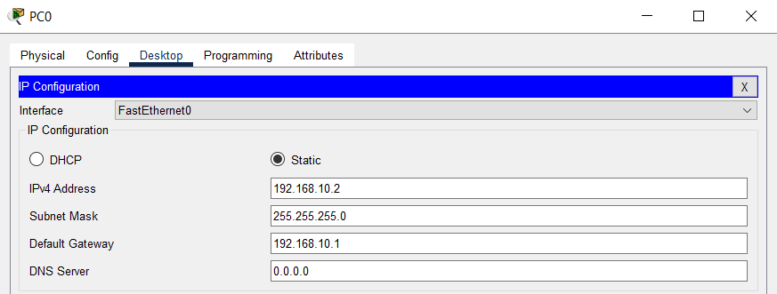

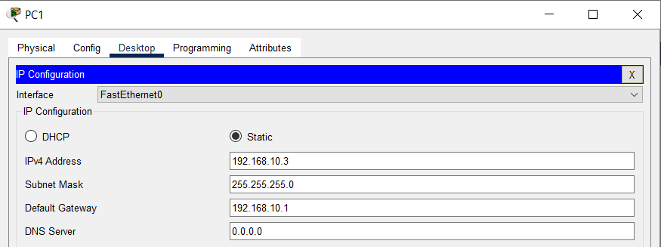

**IP Configuration of PC2 and PC3:**

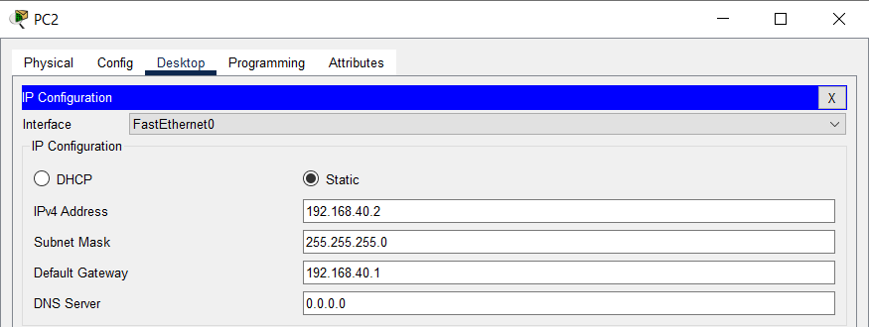

**Checking connectivity by pinging:**

